

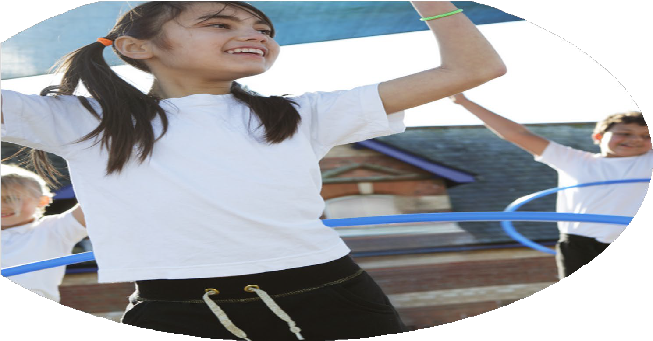
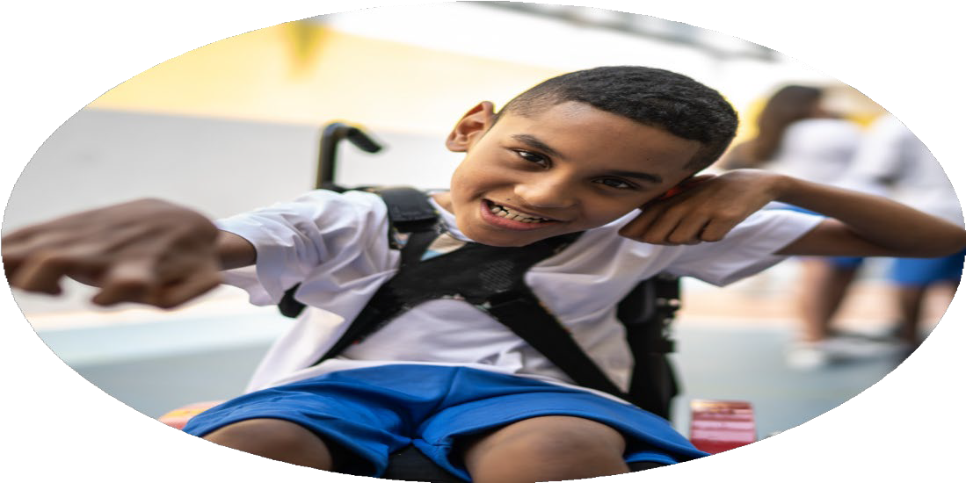
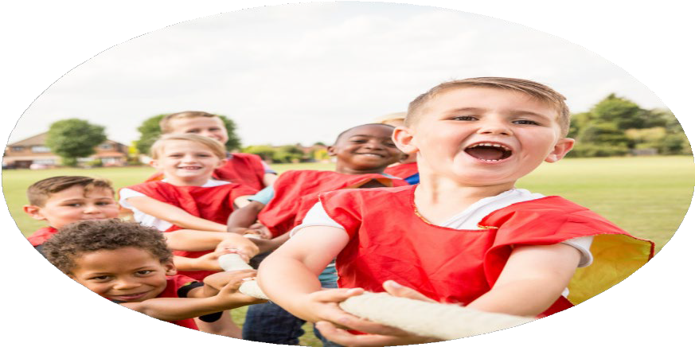



PE Funding

Evaluation Form

Commissioned by

Created by

Images courtesy of Youth Sport Trust

PE Funding Evaluation Form

It is intended that this template should be used as preparation for the completion of the statutory digital reporting tool being introduced this academic year. You can upload data (including swimming) from this template onto this platform once it becomes accessible.
Before you decide how you are going to use the funding for this academic year you should reflect and evaluate the impact of your use of the funding in 2024/25.
All spending of the funding must conform with the terms outlined in the Conditions of Grant document. The template is a working document that you can amend/update during the year.
Based on your evaluation of last year’s funding you should decide what you intend to do this academic year, how you will do it, and what impact you expect it to have.

It is important that the funding is used effectively and based on your school’s needs.
You must use the funding to make additional and sustainable improvements to the PE and sport in your school. You must develop and add to the PESSPA activities that your school already offers.

Summative digital reporting from June 2025 will continue to include swimming and water safety information therefore funding can be used to provide top-up lessons where necessary to ensure pupils meet national curriculum swimming requirements.

We recommend that you start by reflecting on the impact of current provision and reviewing your previous spend

What went well? | How do you know? | What didn’t go well? | How do you know?
All children took part in  regular physical activity.  Children experienced a wide variety of sports through effective planning and delivery.  Y2 and Y3 classes swimming.  Professional coaching from Grassroots.  School Games Mark. | Monitoring of PE lessons and pupil voice identified engagement in physical activity.  Sports covered through curriculum, extra-curricular clubs and external sporting events: dance, gymnastics, athletics, football, tennis, tag rugby, basketball and cricket.  Upward trend of competent swimmers.  Weekly teaching from specialist teacher and access to curriculum planning and CPD.  Silver award. | OPAL | Delayed implementation.

What are your plans for 2025/26? | How are you going to action and achieve these plans?
Intent | Implementation
Continue to ensure all children to take part in regular physical activity, through exposure to a variety of sporting opportunities and increased awareness amongst children of school offer.  Deliver playground games training to all staff.  Continue with professional coaching from Grassroots.  Continue to take part in competitive sporting events.  More children to be competent, confident and proficient swimmers.  To achieve silver in School Games Mark.  Continue with Gateshead SSP membership.  Continue to liaise with local secondary school. | 2 weekly PE lessons (one being swimming for Y4 then Y3). Encouraging children to take part in physical activity during break and lunch times. Exposure to American Football from specialist teacher (Wanna Teach PE).  To be delivered by lead staff and implemented by outside staff.  1 x weekly lesson and 1 x weekly extra-curricular club delivered by specialist teacher from Grassroots.  Children to attend competitive sporting events at least once during the year.  Weekly swimming lessons delivered by local pool trained swimming teachers for Y4 then Y3.  Complete Inclusive Health Questionnaire and apply for School Games Mark.  Attend sporting events delivered by Gateshead SSP, attend termly PE network meetings, access one free coaching block from specialist coach, access CPD and aid with application of School Games Mark.  Attend events delivered by Cardinal Hume School.

What impact/intended impact/sustainability are you  expecting? | How will you know? What evidence do you have or  expect to have?
More pupils meeting their daily physical activity goal, more pupils encouraged to take part in PE and Sport activities. All children receiving specialist PE coaching. More children to attend clubs and special events to give further experiences.  Children to take part in playground games, increasing their daily physical activity.  Children exposed to a range of sports through curriculum planning and delivery (dance, gymnastics, tag rugby, basketball, athletics, cricket, rounders, tennis).  Children to enjoy taking part in competitive sporting events and raise the culture of competitive sporting within school.  Higher pass rate of children being competent, confident and proficient swimmers by swimming over 25m, using a range of strokes effectively and perform safe self-rescue in water-based situations.  Children become aware of award given for School Games Mark.  More children are given the opportunity to attend a sporting event delivered externally.  Teachers are more confident to deliver effective PE, supporting pupils to undertake extra activities inside and outside of school. | Pupil voice  Monitoring of PE lessons  Observations of playground games when outside.  Pupil voice.  Curriculum planning from subject leader disseminated to teaching staff.  Entry to sporting events from subject leader.  Pupil voice  Swimming data collected from swimming teachers identifying which children have fully passed or passed outcomes 1, 2 or 3.  Award given by School Games Mark.  Entry to sporting events from subject leader.  Pupil voice  Fun Run at Saltwell Park  EYFS  Athletics Festival  BWCET Celebration of Sport  Gateshead match tickets  Year 5/6 Hockey

What impact/sustainability have you seen? | What evidence do you have?
All children engaged in daily physical activities and specialist PE coaching. Specialist teaching has continued to engage children in sporting activities, developing their enjoyment and exposure. Sporting after school clubs have had high levels of attendance.  Few children are taken to swimming lessons and the first swimming lesson offered through school is often their first experience of being in a swimming pool.  Well-planned curriculum has allowed the delivery of a range of sports.  Children engaged in playground games and activities.  All children have attended at least one external competitive sporting event.  Higher pass rate of children being competent, confident and proficient swimmers by swimming over 25m, using a range of strokes effectively and perform safe self-rescue in water-based situations.  Silver awarded in School Games Mark | Monitoring of planning and delivery of lessons.  Children spoke about these games during pupil voices and through observations from staff whilst outside supervision.  Certificates awarded.  Swimming data collected by swimming teachers.  Official awarding of Silver from School Games Mark and certificate given.

